H.T No
Regulations:
A18

Sreenidhi Institute of Science and Technology
(An Autonomous Institution)
Code No: 7B310 Date: 11-Sept-2023 (FN)

B.Tech II-Year I- Semester External Examination, Aug/Sept-2023 (Supplementary)
MACHINE DRAWING AND COMPUTER AIDED DRAWING PRACTICE (ME)

Time: 3 Hours Max.Marks:70

Note: a) No additional answer sheets will be provided.
b) All sub-parts of a question must be answered at one place only, otherwise it will not be valued.
c) Missing data can be assumed suitably.

Bloom's Cognitive Levels of Learning (BCLL)

Remember | L1 | Apply | L3 | Evaluate | L5
Understand | L2 | Analyze | L4 | Create | L6

Part - A Max.Marks:30
ANSWER ANY TWO QUESTIONS. EACH QUESTION CARRIES 15 MARKS.

 |  | BCLL | CO(s) | Marks
1 | Draw various types of thread profiles by taking pitch as 30 mm | L3 | CO1 | [15M]
2 | Sketch two views of a Butt-muff coupling indicating proportions for connecting two shafts each of diameter 30 mm | L4 | CO2 | [15M]
3 | Draw the sectional front view and top view of the double riveted double strap zig zag butt joint with dia of the rivet as 14 mm. | L3 | CO3 | [15M]
Part – B Max.Marks:40
Part-B (is Compulsory 40 Marks)

 |  |  | BCLL | CO(s) | Marks
4. | Assemble the parts of screw jack shown in fig, draw its half sectional L5  front view  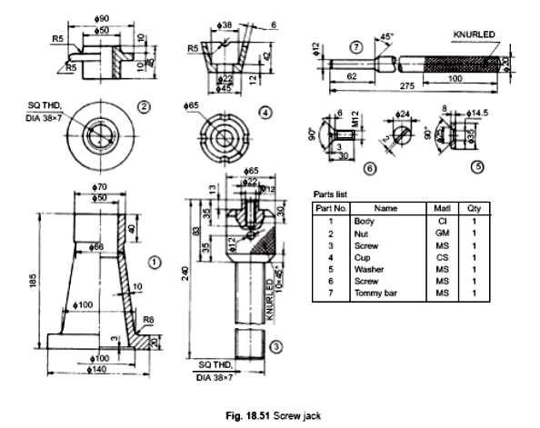 |  |  | CO1 | [40M]

-- 00 -- 00 –

